Name: OYINLADE OPEYEMI
Course: ITCC298 Computer Technology Intermediate Capstone
Date;6/21/2025

This document contains the final website link for the Secure Connect application prototype. The app is designed to help users communicate securely with built-in encryption, hidden messaging, IP scanning, and more. It solves privacy concerns by offering a secure digital space for messaging and file sharing.
Home Page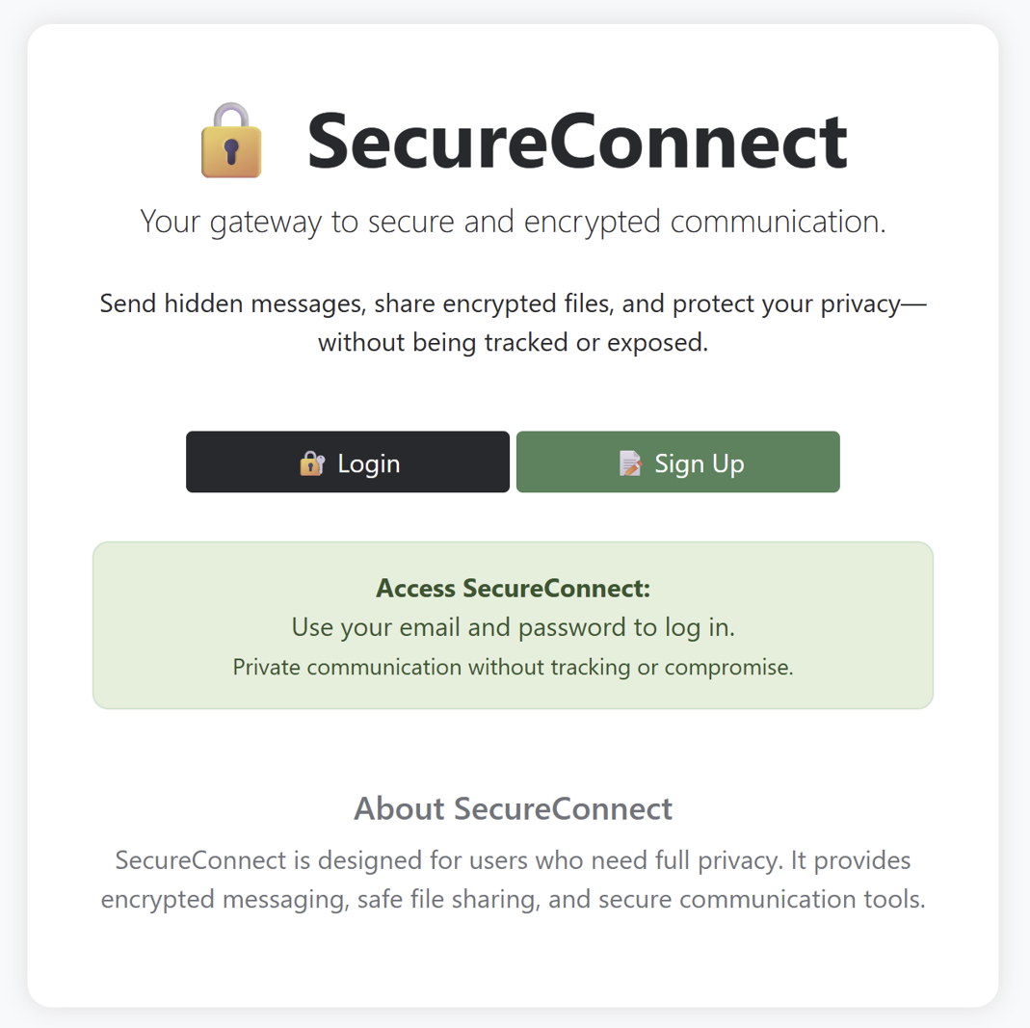

The home page of SecureConnect gives a simple welcome message and lets users know this app is for private and secure messaging. It is clean and easy to understand, with a friendly layout. The goal is to let people know right away that their safety and privacy matters. It also includes a login link that starts the custom login process for extra protection
• About You Page
My name is OYINLADE Opeyemi, a student at American Public University System (APUS). I have a strong passion for cybersecurity and technology. I created SecureConnect to help people communicate safely online without worrying about privacy issues. I'm currently studying computer technology, and I enjoy learning how systems work and how to protect them. Security is important to me because it makes me feel safe and in control when using digital tools.

• Application Prototype Information Page
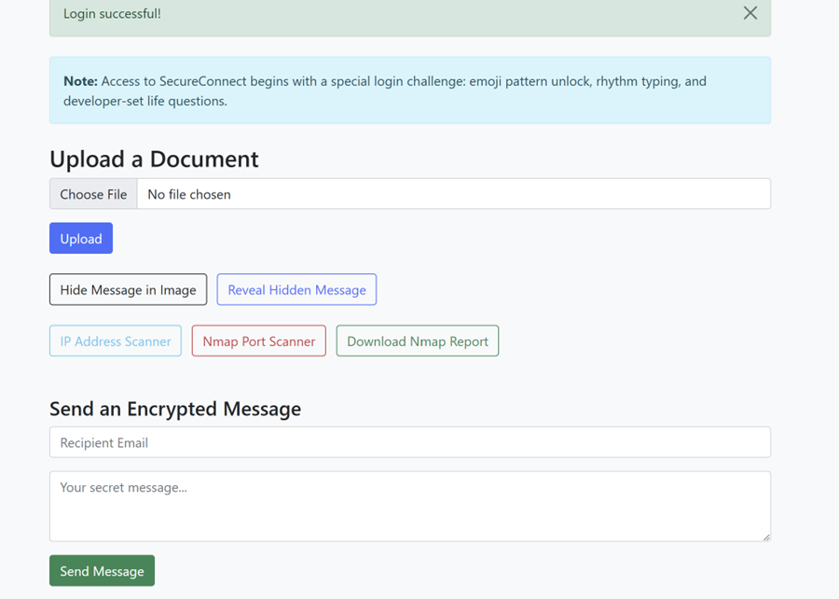

This page gives details about the SecureConnect app. It explains the key features, like sending encrypted messages, hiding messages in images, IP scanning, and using a security question for login. It shows how the app works to keep communication private and how each feature was built to improve user safety online.

• Marketing Page
The marketing page talks about why SecureConnect is useful in today’s world. It shares how people can use it for private conversations without fear of being watched. It points out how the app uses encryption, hidden messages, and extra login security to stay ahead of cyber threats. The message is clear: SecureConnect is for anyone who wants peace of mind while chatting online.
• User Guide Page
The user guide is simple. It helps people understand how to create an account, login with the typing test and security question, send encrypted messages, and hide or reveal messages in images. Each step is explained in plain language so users feel confident using the app. Even first-time users can follow along easily.

Website URL : https://secureconnect-31p5.onrender.com

